Azure AirFLow Capstone Exercise -2
--Yadhav raj D

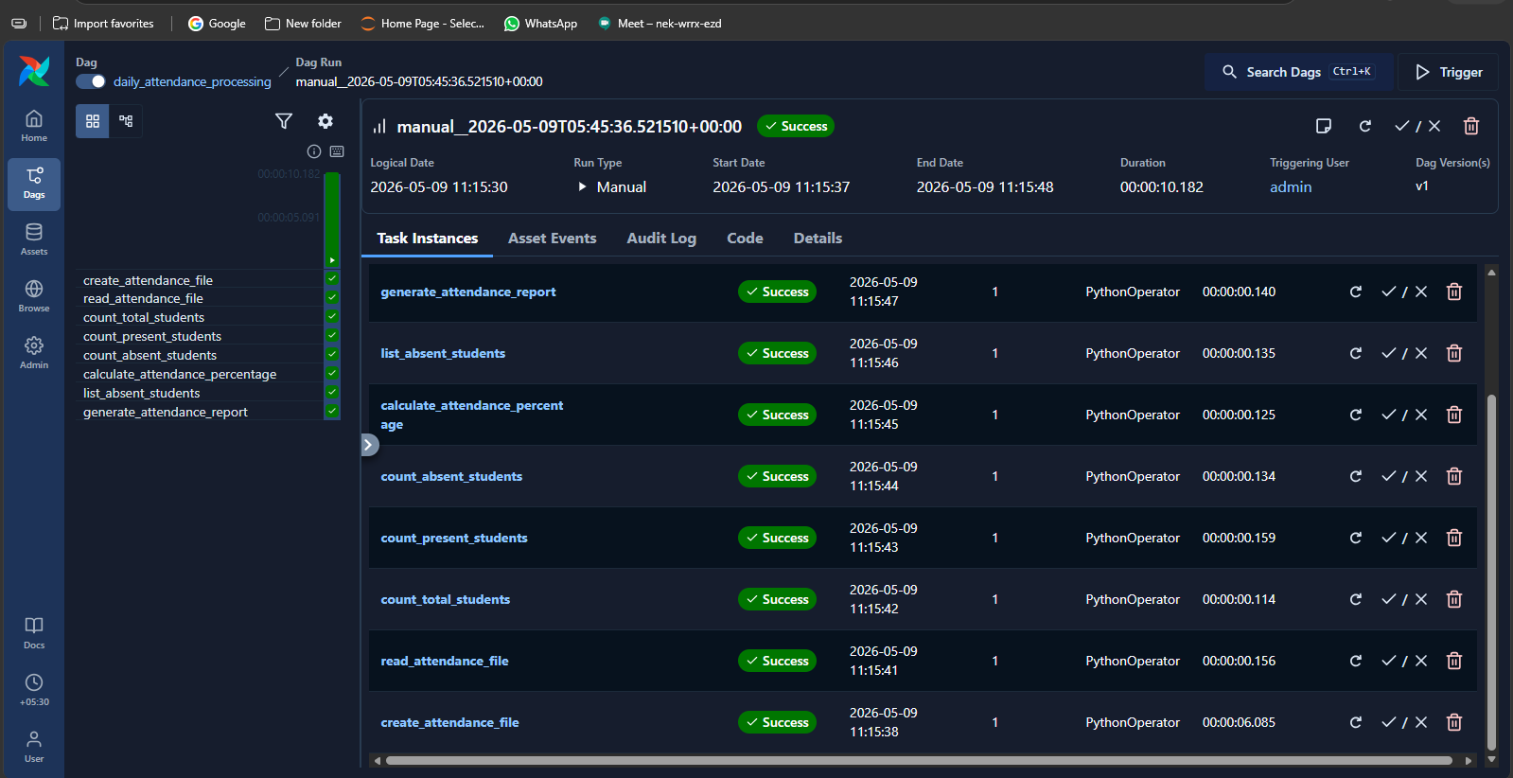

Code:
from airflow import DAG
from airflow.operators.python import PythonOperator
from datetime import datetime

def create_attendance_file():
f=open("/tmp/attendance.txt","w")
f.write("Aarav,Present\nPriya,Present\nRahul,Absent\nSneha,Present\nKiran,Absent\nAnanya,Present\nVikram,Present\nMeera,Absent\nFarhan,Present\nDivya,Present")
f.close()
print("File created")

def read_attendance_file():
f=open("/tmp/attendance.txt","r")
for line in f:
print(line.strip())
f.close()

def count_total_students():
count=0
f=open("/tmp/attendance.txt","r")
for line in f:
count=count+1
f.close()
print("Total Students =",count)

def count_present_students():
count=0
f=open("/tmp/attendance.txt","r")
for line in f:
if "Present" in line:
count=count+1
f.close()
print("Present Students =",count)

def count_absent_students():
count=0
f=open("/tmp/attendance.txt","r")
for line in f:
if "Absent" in line:
count=count+1
f.close()
print("Absent Students =",count)

def calculate_attendance_percentage():
total=10
present=7
percent=(present/total)*100
print("Attendance Percentage =",str(int(percent))+"%")

def list_absent_students():
f=open("/tmp/attendance.txt","r")
print("Absent Students List")
for line in f:
name,status=line.strip().split(",")
if status=="Absent":
print(name)
f.close()

def generate_attendance_report():
total=10
present=7
absent=3
percent=70

status="Needs Improvement"
if percent>=75:
status="Good"

f=open("/tmp/attendance_report.txt","w")
f.write("Daily Attendance Report\n")
f.write("Total Students = 10\n")
f.write("Present Students = 7\n")
f.write("Absent Students = 3\n")
f.write("Attendance Percentage = 70%\n")
f.write("Status = "+status+"\n")
f.close()

print("Report generated")

with DAG(
dag_id="daily_attendance_processing",
start_date=datetime(2025,1,1),
schedule=None,
catchup=False
) as dag:

t1=PythonOperator(task_id="create_attendance_file",python_callable=create_attendance_file)
t2=PythonOperator(task_id="read_attendance_file",python_callable=read_attendance_file)
t3=PythonOperator(task_id="count_total_students",python_callable=count_total_students)
t4=PythonOperator(task_id="count_present_students",python_callable=count_present_students)
t5=PythonOperator(task_id="count_absent_students",python_callable=count_absent_students)
t6=PythonOperator(task_id="calculate_attendance_percentage",python_callable=calculate_attendance_percentage)
t7=PythonOperator(task_id="list_absent_students",python_callable=list_absent_students)
t8=PythonOperator(task_id="generate_attendance_report",python_callable=generate_attendance_report)

t1>>t2>>t3>>t4>>t5>>t6>>t7>>t8

